Machine Learning Safety
Exercise sheet 7

Exercise 9.1: The OOD Problem Your CARLA model was trained on sunny daytime images. At deployment, it may encounter images from fog or night- conditions outside its ODD.
1. Why can a standard classifier not be trusted to signal when it receives an OOD input?
Answer
A standard classifier cannot be trusted to detect OOD inputs because it is trained only to distinguish between the classes seen during training. It is not trained to recognize when an input comes from a different distribution. As a result, the model may assign high confidence to completely unfamiliar inputs and still produce a prediction. Therefore, high confidence does not necessarily indicate that the input is valid or in-distribution.

2. Why is silent failure (confidently wrong prediction) worse than uncertain failure in a safety-critical system?
Answer
Silent failure is more dangerous because the model makes an incorrect prediction with high confidence, giving the system no indication that something is wrong. In a safety-critical application such as autonomous driving, the planner may fully trust the prediction and take unsafe actions. In contrast, an uncertain failure provides a warning signal that can trigger safety mechanisms such as slowing down, requesting human intervention, or switching to a fallback mode. Therefore, uncertain failures are generally safer than confident but incorrect predictions.

Exercise 9.2: Baseline OOD Detection Describe the maximum softmax probability (MSP) baseline for OOD detection. How does it work, and what are its main limitations?

Answer
How it works
- MSP (Maximum Softmax Probability) is a simple OOD detection baseline.
- A classifier first produces class probabilities using the softmax function.
- The highest probability is used as a confidence score.
- Inputs with high confidence are considered in-distribution(ID), while inputs with low confidence are considered out-of-distribution(OOD).
Limitations
- MSP assumes that OOD samples will have low confidence.
- In practice, neural networks often assign very high confidence to unfamiliar inputs.
- Therefore, OOD samples may still receive high MSP values and be classified as in-distribution.
- This can lead to silent failures, where the model is confidently wrong.

Exercise 9.3: Alternative Methods Describe one more advanced OOD detection method (e.g., energy score or Mahalanobis distance). How does it improve over MSP?
Answer
The Mahalanobis method is a feature-based OOD detection technique. Instead of using output probabilities, it analyzes deep feature representations extracted from the neural network. The method estimates a mean feature vector and covariance matrix for each class using in-distribution training data. For a new sample, the Mahalanobis distance to the closest class distribution is computed. Samples with large distances are considered out-of-distribution.
Compared to MSP, Mahalanobis uses information from the feature space rather than only the final softmax probabilities. As a result, it can often detect OOD samples even when the classifier assigns them high confidence. This generally leads to better OOD detection performance than MSP.

Exercise 9.4: Visualising the Distribution Shift
1. Display five in-distribution (sunny / daytime) images next to five fog and five night images.

Answer
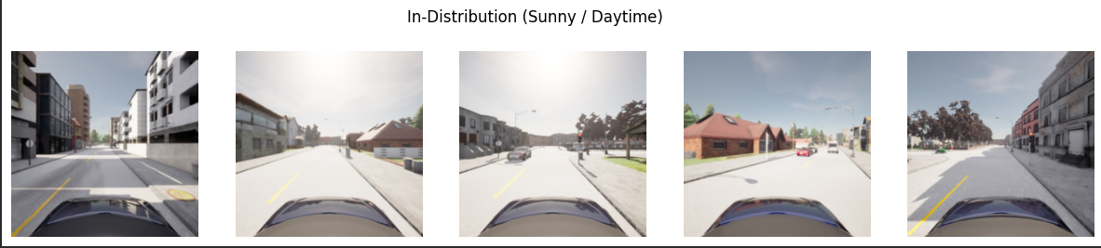
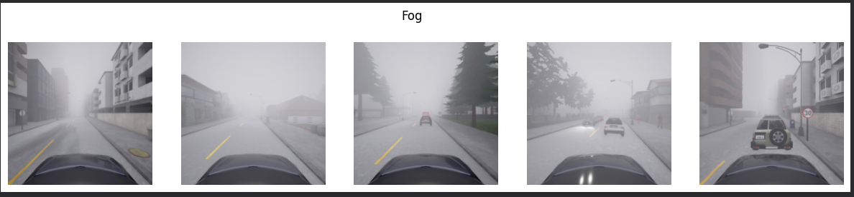
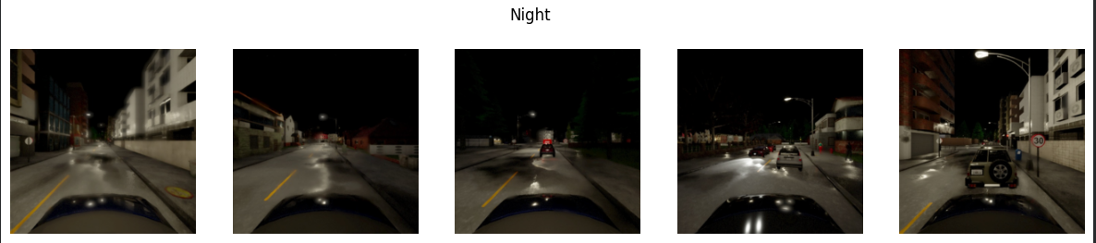
Five in-distribution (sunny/daytime) images were compared with five fog images and five night images. The sunny images are well illuminated, have high visibility, and clearly show roads, buildings, vehicles, and pedestrians. These images closely match the conditions used during training.
The fog images exhibit reduced visibility and lower contrast. Distant objects appear partially obscured, making object recognition more challenging. The overall scene appears washed out compared to the sunny images.
The night images show the largest visual shift. Illumination is significantly reduced, large portions of the scene are dark, and object boundaries are harder to distinguish. Artificial light sources such as streetlights and vehicle lights become more prominent.

2. Also display five images from the different CARLA town. How do they differ from your training images, and how does that difference compare to the fog / night shift?
Answer
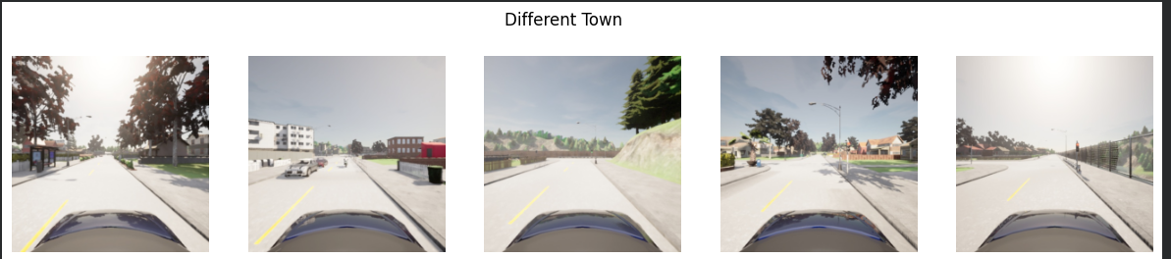
The images from the different CARLA town show noticeable changes in the environment compared to the training images. The road layouts, building structures, vegetation, and overall scene composition differ from those observed in the training town. These changes introduce a distribution shift because the model encounters new surroundings that were not present during training.
However, the weather conditions, illumination, and image quality remain similar to the original training data. As a result, the shift is primarily related to environmental context rather than visibility.
Compared to the fog and night datasets, the different-town dataset represents a milder distribution shift. Fog reduces visibility and contrast, while night significantly changes illumination and scene appearance. In contrast, the different-town images remain clear and well illuminated, making the shift less severe than the fog and night conditions.

3. Compute the mean softmax confidence of each of your three models on in-distribution vs. fog/night images. Is the model more or less confident on these inputs?
Answer
Model | Sunny | Fog | Night
Pedestrian | 0.814 | 0.980 | 0.954
Vehicle | 0.911 | 0.739 | 0.760
Traffic Light | 0.965 | 0.853 | 0.882

For the vehicle and traffic-light models, confidence decreases under fog and night conditions, which is expected because the inputs differ from the training distribution. This suggests that the models become less certain when encountering OOD data.
The pedestrian model exhibits the opposite behavior. Its confidence increases substantially on fog and night images, despite a significant reduction in detection performance observed previously. This indicates that the model is overconfident on OOD inputs and may produce confidently incorrect predictions.
Overall, the results show that confidence alone is not a reliable indicator of correctness. While some models become less confident on OOD data, others may remain highly confident or even become more confident despite making more errors. This motivates the need for dedicated OOD detection methods rather than relying solely on prediction confidence.

Exercise 9.5: Is the Different Town Out-of-Distribution? The different-town images were taken under nominal weather and lighting- the kind of conditions your system is meant to handle- but in a location your models never saw during training.
1. Look back at the ODD you specified in Exercise 2.2. As written, does your ODD clearly decide whether the different-town images are inside or outside it?
Answer
The original ODD does not explicitly specify whether the vehicle is restricted to a particular CARLA town. The ODD defines the operating environment as sunny daytime driving on urban roads and mapped intersections. The different-town images satisfy these conditions because they contain urban roads, intersections, and normal daytime weather.
Therefore, the original ODD does not clearly determine whether the different-town images are inside or outside the ODD. While they appear to fit the described operating conditions, the ODD does not explicitly address changes in town layout, road geometry, or environmental context.

2. Revise the wording of your ODD so that the new town is unambiguously either inside or outside it. State which you chose and why.
Answer
Revised ODD:
- Sunny weather and daytime conditions.
- Forward-facing RGB camera functioning normally.
- Urban roads and mapped intersections in any CARLA town.
- Vehicle speeds up to 50 km/h.
- No heavy rain, fog, snow, or nighttime conditions.
Choice: The different-town images are considered inside the ODD.
Justification: Although the town layout differs from the training data, the weather, lighting, sensor setup, and driving task remain unchanged. Since the ODD is intended to cover urban driving under normal daytime conditions, the system should be able to operate in previously unseen towns that satisfy these conditions.

3. What does that choice imply for how the town images should be treated- as inputs the system must handle correctly, or as inputs an OOD monitor should flag?
Answer
Since the different-town images are considered to be inside the revised ODD, they should be treated as inputs that the system is expected to handle correctly. The perception models should generalize to these images and maintain acceptable performance despite the change in environmental layout.
Consequently, the different-town images should not be flagged by an OOD monitor. An OOD monitor should instead focus on conditions that violate the ODD, such as fog, nighttime driving, heavy rain, or other situations that significantly differ from the intended operating environment.
If the system performs poorly on the different-town images, this indicates a lack of generalization rather than an OOD detection problem. The appropriate response would be to improve the training data or model robustness rather than relying on the OOD monitor to reject these inputs.

Exercise 9.6: Evaluating the MSP Baseline Pick any one of your three models and use its maximum softmax probability as an OOD score (low confidence → OOD). Treat the sunny/daytime test images as in-distribution and the provided OOD images as OOD.
1. Plot the distribution of OOD scores for in-distribution and OOD images
Answer
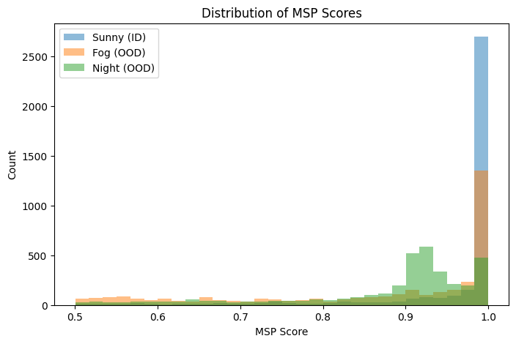
The MSP score distributions for in-distribution (sunny) and OOD (fog and night) images were plotted using the traffic-light model. The in-distribution samples are heavily concentrated near an MSP score of 1.0, indicating that the model is generally very confident on data similar to its training distribution.
The fog and night distributions are more spread out and contain a larger number of lower-confidence predictions. This suggests that the model is generally less confident when presented with OOD inputs.
However, there is substantial overlap between the ID and OOD distributions, particularly near MSP values close to 1.0. This indicates that some OOD samples still receive very high confidence scores. Therefore, MSP provides useful information about distribution shift but cannot perfectly separate ID and OOD data.

2. Compute the AUROC for separating in-distribution from OOD, over all of the OOD scenarios.
Answer
The AUROC values obtained using Maximum Softmax Probability (MSP) as an OOD score are:
Comparison | AUROC
Sunny vs Fog | 0.761
Sunny vs Night | 0.823
The results show that MSP can distinguish in-distribution and OOD samples better than random guessing. The detector performs better on night images than on fog images, indicating that the night dataset introduces a stronger distribution shift relative to the training data.
However, neither AUROC value is close to 1.0, indicating that there is still substantial overlap between ID and OOD samples. Therefore, MSP provides useful but imperfect OOD detection performance.

Exercise 9.7: Feature-Based OOD Detection Implement one feature-based detector (Mahalanobis distance or k-NN, both covered in the lecture) and compare it to the MSP baseline.
1. Extract deep features for your in-distribution training (or validation) images and for the test in-distribution and OOD images. Use the same model whose MSP you evaluated in Exercise 9.6
Answer
A feature-based OOD detector was implemented using the traffic-light ResNet18 model. Instead of using the final classification output, features were extracted from the penultimate layer of the network by removing the final fully connected classification layer.
Feature vectors were extracted for:
- In-distribution training images (1024 samples used for fitting the detector),
- In-distribution test images,
- Fog OOD images,
- Night OOD images.
Each image was represented by a 512-dimensional feature vector. These feature representations were then used to train and evaluate a k-nearest neighbors (k-NN) OOD detector.

2. Fit the detector on the in-distribution features only, then score the test images (larger distance → more OOD).
Answer
A k-NN detector was fitted using the feature vectors extracted from the in-distribution training images. The OOD score was defined as the average distance to the five nearest neighbors in feature space.
The mean distances obtained were:

Dataset | Mean Distance
Sunny (ID) | 1.765
Fog | 2.170
Night | 5.945
The results show that the OOD images generally have larger distances than the in-distribution images. In particular, the night dataset exhibits a much larger average distance, indicating that its feature representations differ substantially from those observed during training.

3. Compute its AUROC and compare it to the MSP AUROC from Exercise 9.6. For which OOD scenario is the gap largest?
Answer
Comparison | MSP AUROC | k-NN AUROC
Sunny vs Fog | 0.761 | 0.709
Sunny vs Night | 0.823 | 0.993

For the fog dataset, MSP slightly outperformed the k-NN detector. This indicates that fog images remain relatively close to the in-distribution feature space, making them harder to distinguish using feature distances alone.
For the night dataset, the k-NN detector substantially outperformed MSP. The AUROC increased from 0.823 to 0.993, indicating nearly perfect separation between in-distribution and night images. This result suggests that night images produce feature representations that differ significantly from those observed during training.
The largest performance gap is therefore observed for the night scenario, where feature-based OOD detection is considerably more effective than MSP. Overall, the results demonstrate that feature-space methods can provide stronger OOD detection performance when the distribution shift produces large changes in the learned feature representations.

Exercise 9.8: Extending the Safety Analysis for OOD You have now seen how easily the perception models fail- silently- on out-of-ODD inputs, and how well (or poorly) an OOD monitor can catch them. Revisit your System-Theoretic Process Analysis from Sheet 2 and extend it to cover this risk. Many of you will not yet have an OOD-related entry in your analysis; the goal of this exercise is to add one and trace it through.
1. Hazard. Check the hazards from Exercise 2.4. Is operating on an undetected out of-ODD input captured (e.g. as a cause of “vehicle fails to brake for a pedestrian”)? If your hazard list does not reflect it, refine or add a hazard
Answer
The existing hazard list does not explicitly capture the risk of operating on an out-of-distribution (OOD) input that is not detected by the system. While H-3 addresses unclear or obstructed camera input, it does not cover cases where the perception model receives valid images from conditions outside its training distribution (e.g., fog, nighttime, or other unexpected environments) and produces unreliable predictions.
Therefore, the following hazard is added:
H-5: The vehicle operates using unreliable perception outputs caused by undetected out-of-distribution inputs.
This hazard can contribute to H-1 (pedestrian detected too late) and H-2 (vehicle fails to stop when another vehicle is directly ahead), since incorrect perception outputs may lead to unsafe driving decisions.

2. Unsafe control action. Review the UCAs from Exercise 2.6. Add a UCA for the case where the planner acts on perception output that is unreliable because the input is out-of-distribution and this is not detected (e.g. “the planner continues at speed while the camera input is out-of-ODD and the perception output is untrustworthy”). Link it to the hazard(s) above.
Answer
A new unsafe control action is added to capture the risk of operating on undetected OOD inputs.
ID | Controller | Control Action | UCA Type | Hazard(s) | Unsafe Scenario
UCA-9 | Planning Module | Continue driving | Provided unsafely | H-5, H-1, H-2 | The planner continues normal operation even though the perception input is out-of-distribution and the resulting perception outputs are unreliable.
This UCA reflects the situation where the perception system produces incorrect or misleading detections under OOD conditions (e.g., fog or nighttime), but the planner continues to trust these outputs and makes driving decisions based on them.

3. Safety constraints. From that UCA, derive at least one new safety constraint of each kind (cf. Exercise 2.7):
• a model-level constraint on the OOD monitor, justified by the severity of the hazard it guards against; and
• a system-level constraint on the response.

Answer
Based on UCA-9, the following safety constraints are derived.
Model-Level Safety Constraint
The OOD monitor shall detect and flag inputs that significantly deviate from the training distribution before perception outputs are used by the planning module.
This constraint is necessary because undetected OOD inputs may cause unreliable perception results, which can lead to hazards such as delayed pedestrian detection or failure to stop for vehicles.
System-Level Safety Constraint
When an OOD condition is detected, the vehicle shall enter a safe operating mode. Possible responses include reducing speed, increasing safety margins, requesting operator intervention, or performing a controlled stop if safe operation can no longer be guaranteed.
This constraint ensures that OOD detection results in a risk-reducing action rather than merely generating a warning.

4. Residual risk. Even with a perfect OOD detector, what risk remains? Does detecting OOD fully address the UCA and hazard?
Answer
Even with a perfect OOD detector, residual risk remains. Detecting an OOD input does not automatically prevent unsafe behavior; the system must still respond appropriately. For example, if an OOD condition is detected but the vehicle fails to reduce speed or enter a safe state, the hazard may still occur.
In addition, not all perception failures are caused by OOD inputs. Errors can also occur within the intended operating domain due to occlusions, sensor noise, or model limitations. Therefore, OOD detection reduces risk but does not eliminate it completely.
As a result, detecting OOD inputs helps mitigate hazards such as H-1 and H-2, but it cannot fully guarantee safe operation in all situations.

